ABSTRACT

Washing and drying clothes is a necessary everyday activity. A Istat statistical survey state that 96,2% of Italian family have a washing machine while only 3,3 % have an automated dryer. Drying clothes could take a long amount of time and space, especially for those who live in apartment. Our study aims to create a low-cost smart system to optimize this process. By creating modules of different size and shape our system will fit different dryer rack and customer necessity. We have studied the process of clothes drying, both theoretically and experimentally, to understand the most important variables and processes. Our module will contain: Humidity and Temperature sensor selected for this environment, a fan capable of remove humid air near clothes, a microcontroller and a battery to power the module.

INTRODUCTION

The reason why so few families own an automated dryer is that, although this appliance allows for fast drying of the clothes, it has a considerable economic weight both for purchase and for consumption.

The remaining part of the families still use simple drying racks because they are cheap and do not consume. They are a good way to dry clothes on sunny and breezy days, but they are very inefficient during the darkest and coldest times of the year. This results in very slow drying times. This turns out to be a problem especially for large families, where generally one washing machine load is not enough to dispose of all the laundry. Furthermore, it is also harmful to the environment in which they are dried, since wet clothes in a poorly ventilated environment cause a considerable increase in humidity and this can cause the onset of mold and corrosion.

The goal of the work is to find a solution to this problem, making clothes drying more efficient, while still lower costs and consumption, so as not to have to resort to buying a dryer. From the consideration that drying the clothes on the drying rack outdoors is the best solution on breezy days, we have thought of creating a system of components capable of achieving similar conditions, by using ventilation.

Cloth drying involves two processes. Energy must be provided to change the water from liquid to steam, and a flow of air is required to remove the steam.

The phenomenon underlying the drying of wet clothes is the evaporation of the water contained in them. The release of the high-energy water particles causes a drop in temperature which also results in a slowdown in the evaporation process. For this reason, it is useful to use a heat source capable of preventing the temperature drop, keeping clothes in thermal equilibrium with the environment.

Ventilation, on the other hand, is essential to provide a surface air flow capable of removing the water molecules that evaporate, avoiding the generation of a possible balance between the molecules that are released into the environment and those that recombine in the water on the clothes.

What we are going to do is use humidity sensors to measure the change in humidity of the environment during the drying process, and temperature sensors to record the temperature of the clothes as the water evaporates. Based on the data that the sensors provide us in the various measurement steps , the system implemented by us will evaluate the level of ventilation to be supplied to the clothes based on the drying phase reached. In this way, it will also be possible to automatically control the shutdown of the system when evaporation is complete and the humidity level has returned near to the value obtained in the absence of wet clothes.

The approach to the problem was initially of a theoretical type, through the study of physical models capable of describing the thermodynamics of the process, and later empirical tests were carried out for the collection of data and the verification of the effectiveness of the drying system.

RELATED WORKS

There are already several devices designed to solve the problem of drying clothes.

The first, the simplest, is the simple drying rack. The idea is to hang the clothes so that the entire outer surface of the clothes is exposed to the external environment. This is why the drying rack is functional to use it outdoors, on hot and breezy days. So this simple device exploits three fundamental parameters for drying: complete exposure of the cloth to external contributions, heat and the convective motion of the air. The problem is that while the first parameter is controllable through a good drafting of clothes, the second and third are beyond human control, therefore it turns out to be impractical during cold days. Therefore, by moving the drying rack indoors, it is possible to control the second parameter, that is the heat, by varying the internal temperature of the house, but it would still be in a poorly ventilated environment, and this prolongs the drying time. The strong points of this device are the economy and the zero consumption, a significant weak point is the inefficiency during long periods of the year.

The second device that has been developed for this purpose is the dryer. The clothes dry thanks to a heat source (consisting of an electric coil resistance, in the traditional models, or a heat pump circuit, in the more recent models) which heats the air and introduces it into the drum through a fan . The main function of the heat pump is to heat the dry air that is introduced inside the drum and to cool the air coming out of the drum, loaded with the humidity extracted from the clothes, to condense it and collect it in liquid form in the appropriate container or discard it. The advantages of the dryer are considerable from the point of view of efficiency and drying speed, thanks also to programs that can be adjusted according to the load and type of cloths In this case, a significant weak point is the high price and cost also due to the high consumption.

The third device designed to solve the problem of drying clothes is the electric drying rack, and it is the one that comes closest to our project. The electric drying rack, based on the type of operation used, has different drying systems. There is the model with heated rods, the type that instead uses forced ventilation, hot or cold, and the one with a heat chamber.

Based on these existing models, we assessed what features our model would have to have in order to compete with them and provide something new on the market. Our initial idea was to develop an alternative drying rack to electric ones, but it would not have the necessary characteristics to compete with them, both in terms of efficiency and price. So we thought of a project suitable for those people who want to solve the problem of drying clothes, without investing excessively on it, and we thought of "decorating" the classic drying rack that every family has at home, with modules that can guarantee the efficiency that it demonstrates outdoors on typical breezy days. These modules, containing fans of different types and sizes, must be comfortable to hang, must be un cumbersome, have to make little noise and have low consumption. In this way they can compete strongly with existing models, re-establishing the needs of those who do not intend to invest in a totally new drying system, but simply by 'enriching' their simple drying rack, obviously at a low price.

Physical description

The temporal variation of the clothes drying process was studied through the evolution of the two main involved parameters, temperature and humidity. According to the kinetic theory, temperature is the expression of the average energy of the molecular movement. Relative humidity (RH) is the ratio of the actual water vapor pressure to the saturation pressure of water vapor at the prevailing temperature. The RH decreases as the temperature increases.

Through a humidity and temperature sensor, their values were measured during the entire drying process of clothes hung on a drying rack in a closed environment and the following results were obtained:

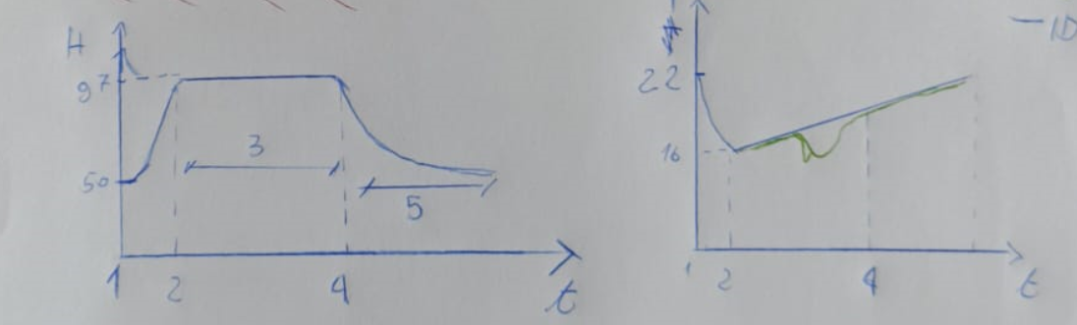fig.1

*(dato che qui hai ottenuto un buon andamento ci sta inserire i grafici).*

As can be seen from the graph on the left, humidity undergoes a significant increase compared to the initial value (50%), which is relative to the humidity level of the room in the absence of wet cloths. This significant increase in humidity corresponds to a clear decrease in temperature of about 4 degrees. Both variations can be associated with the phenomenon of evaporation. Only molecules with a high kinetic energy will escape from the liquid water surface, against the cohesive force that binds the molecules in liquid water. As soon as this happens, the remaining molecules re-distribute their energy by collision, to a lower temperature, because the average molecular energy is lower. From the calculations on the Maxwell-Boltzmann distribution it can be deduced that the proportion of high energy molecules is much diminished in the material, even when the temperature decreases by only 4 degrees. Therefore the number of released water molecules in the environment increases considerably, and this can justify the increase in relative humidity up to values close to 100%.

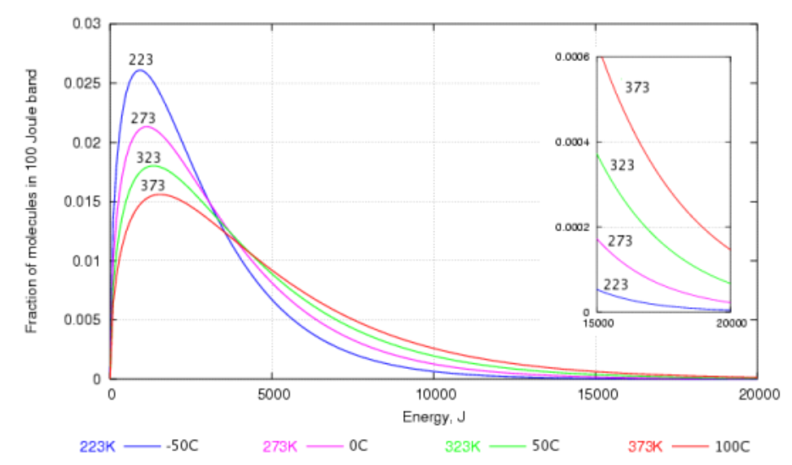 fig.2

The energy distribution of water molecules at various temperatures. The high energy region is enlarged in the inset graph.

However, while the temperature during the drying process gradually returns to its initial value, in equilibrium with the external environment, the humidity maintains a very high constant value for a long time. This means that a balance is created between the water molecules released by the wet cloth and those that return to it. The permanence of the water molecules near the cloth makes drying more difficult. These considerations led us to consider that the generation of convective air motions can significantly increase the drying speed, as it allows the water molecules to move away from the cloths, once released.

In particular, on a drying rack, the most critical area is the one present between a cloth and the other, since they are less exposed to the external environment and therefore also to its convective motions, and water molecules, resulting from evaporation water in both cloths, accumulate.

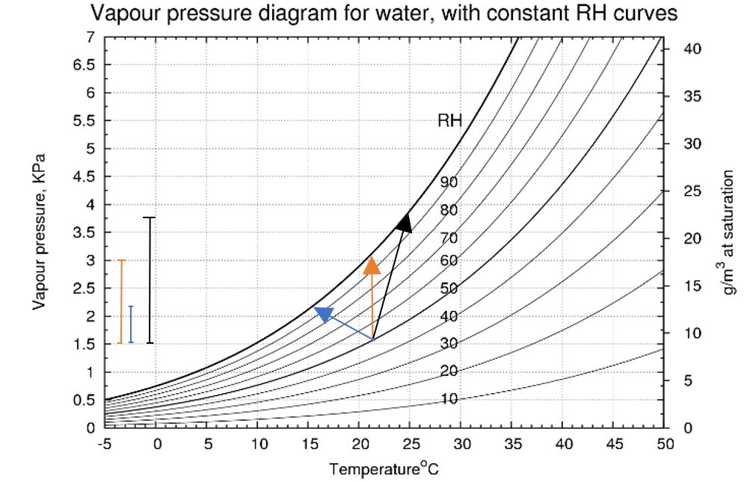fig.3

C

B

A

Figure 3 shows how the temperature and the water content of the air stream change as it passes over the cloth. This diagram is a portion of the vapour pressure diagram for water. The air in this example approaches the wet cloth at 22°C and at 55% relative humidity (RH). This is the apex where the three arrow lines meet. As the air passes over the surface of the freely suspended wet cloth it transfers heat to the cloth, moving down the temperature axis, and it gains water from the cloth, so it rises along the vertical, water content axis. The condition of the air moves to the head of the arrow at point **A**, because the air stream leaving the cloth is at 100% RH. This is true whatever the air speed.

Since ventilation involves the transport of air from the environment to clothes, this process also allows a faster achievement of the thermal balance between the environment and clothes, and turns out to be advantageous for the subtraction of water from them through the wind (arrow B).

To further increase the removal effectiveness of evaporating water particles from the surfaces of the clothes, a heat source could also be included to increase the temperature of the clothes (arrow C). Given that, as we will explain below, some of the objectives of our project are low cost, low consumption, and ease of use, we decided to focus only on increasing the drying speed due to the convective motion of the air, more than to the increase of the temperature of the clothes.

This choice is also justified by the experimental results obtained by measuring the mass of a cloth during drying using first only heat and then only ventilation (fig.5). It may be noted that ventilation speeds up drying of the cloth more.

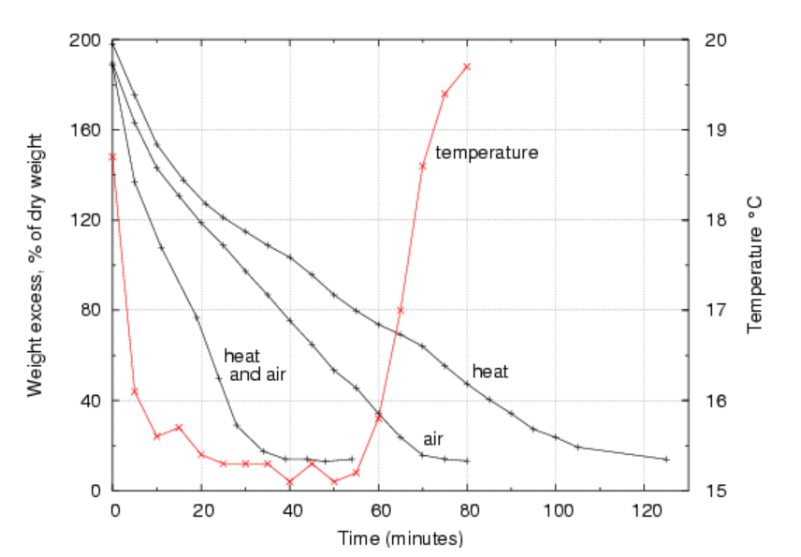Fig.4 (ho i dati di questo esperimento)

SYSTEM SPECIFICATION

Functional specifications  
The system have to:

* make the drying process faster,
* understand when the clothes are dry,
* notice the user that the clothes are dry.

Non functional specifications.  
In order to be competitive with other product the system have to be:

* cheap: less than 30 euro.
* small: easy to move and to keep in small home.
* energy and time efficient.
* adaptable for different drying rack.
* user friendly: easy to use

GENERAL ARCHITECTURE

Sensor I

Microcontroller

Dryng component

Battery

Packaging

User output

Sensor II

A module is composed of four parts: the microcontroller, two sensor, the drying system, the power supply, the output to communicate to the user that the clothes are dry.

The sensor I must be placed close to the surface of the clothes to evaluate the drying, so it will be connected to the processor with a cable, and it will be possible to place it on the clothes through the use of a clothespin attached.

SYSTEM CHARACTERISTICS

A module will cover just a portion of the rack, the customer will need multiple modules to cover all the rack, in this way the module will be small enough to be applied to different type of rack and different amount of clothes

=Module

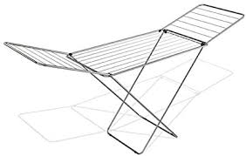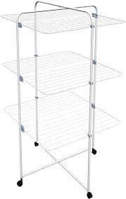

We chose as drying component a fan because they are cheap, easy to use, quiet and can be found of different size.  
The fan is oriented downwards so that the air flows into the space between the clothes. The air flows push away the humid air near clothes and speed up the drying process, also the air between clothes is colder that the air pushed inside by the fan so the temperature will also be higher speeding the drying process.

The sensor must be placed inside one of the clothes so that is not measured the humidity of the air between the clothes, that is keep at a constant low value by the fan, but the actual humidity of the clothes. Since each module have only one sensor and operate on multiple column of clothes, we assume that each column will have the same condition and will dry in the same time. This of course is not true since there are different type of clothes; so in the user manual will be specified to put the sensor inside the heaviest clothes for example: jumpsuit, sweathshirt or towel so that if the heavist clothes are dry also the ligheter one are dry.

The fans will work under the control of temperature and humidity sensors. The clothes are dry when the relative humidity of the air near the clothes RHc is equal to the relative humidity of the environment RHe and stay constant. From the experiment we notice that even the clothes fell dry by touching them even if RHc=RHe+10.  
The algorithm principle are: the fan will blow until the humidity reach RHe+10 then the fan is shut down, if RHc stay constant or decrease for a sufficiently long time T the drying process is complete, if instead after T the humidity rise then from experiment we found the optimum T to be 10 minutes.

As we said in the theory no efficient energy saving strategy can be implemented: there is a trade-off between energy consumption and drying time. So we decided to let the customer choose between three modalities:

* fast drying: the fan is always on;
* normal regime: 3 minutes on and 1 off, repeat until the drying is complete;
* energy saving: 1 minutes on and 3 off, repeat until the drying is complete;

From theory with

Consumed energy:

Calling the time yeld and the energy yeld, for the different modality:

* fast drying: ;
* normal regime:;
* energy saving:;

and are obtained experimentally.

Prototype

For our prototype the microcontroller is Arduino Uno which is connected with jumper wires to a breadboard connected to all the other part of the system.

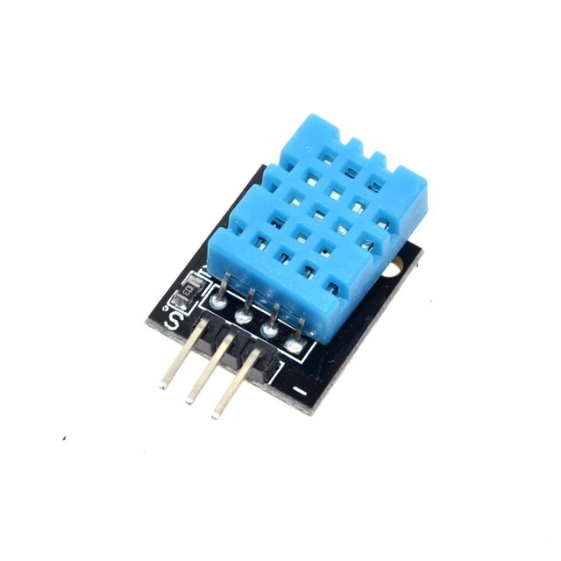The relative humidity in the system vary on an interval of 40%-100% and the temperature of 15°C- 30°C (room temperature). Relative humidity and Temperature vary slow during the drying process, so we don’t need a fast sensor; but we need a cheap and small sensor with a big range and a good sensibility, that work at room temperature. We choose the DHT11, which has an operating voltage of 3.3-5 V DC, a measurement range of 20-95% for the relative humidity and 0-50°C for the temperature with a sensibility of 1% for humidity and 1°C for temperature; so compatible with our request.

The criteria to choose the fan are:

* The air flow: it must significantly reduce the drying time.
* The energy consumption: since it must operate for a long period of time it must have a low energy consumption.
* The alimentation voltage.
* The size: sufficiently small to be moved easily but sufficiently large to cover multiple rag.
* The noise: a noisy fan could be annoying to the customer.
* 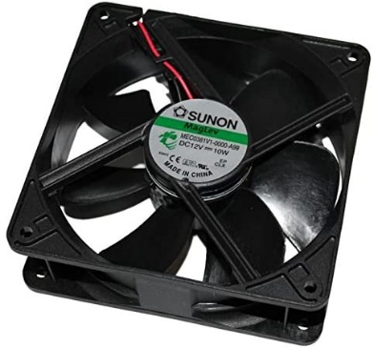Cost.

We choose the Sunon MEC0381V1-A99 which has a great air flow (234 , a good dimension:12x12x3,8 cm (can cover 2-3 rack of an ordinary drying rack ) and is quiet: 50 dB. The downside are: the cost is half of the budget (14,80 on amazon 7,86 on digi-key Italy), the alimentation voltage: 12V, so it must be powered separately from Arduino and it must controlled with a MOS; we used the IRF520 that can hold a 20 V difference between source and drain.

The user output is a led that will turn green when the process is complete

PAKAGING

For the power source we used a 8XAA battery holder.

PHOTO AND SCHEMATIC

The microcontroller and the battery are be placed beside the fan to avoid interference with the air flow. The system is packed inside a light waterproof material with hole above and below the fan.

Experiments

The goal of the experiments are:

* Show that the physics model is correct and so our system is useful
* Find and
* Show that the finalization algorithm is correct.

To do so we measured the time to dry two cloth soaked with 4g of water with different operating regime. To soak the cloth with the same amount of water at every experiment we used a spray bottle and balance: we spray some water and weight until the mass has increased by 4g. Also we want to observe the behaviour of humidity and temperature during time, so we used the program plx-daq to save the output of Arduino in an excel file. As said previously the clothes are dry when RHc<RHe+10.

In the following chart are reported the result

|  |  |  |  |  |  |  |  |
| --- | --- | --- | --- | --- | --- | --- | --- |
| **OPERATING**  **REGIME** | Fan  always off  q=0 | 2 min off  1 min on  q=0,33 | 1 min off  1 min on  q=0,5 | 2 min off  2 min on  q=0,5 | 3 min off  3 min on  q=0,5 | 2 min off  1 min on  q=0,66 | Fan always on  q=1 |
| **TIME** | 113 min | 48 min | 33 min | 38 min | 32 min | 30 min | 21 min |

So indeed the drying system do his job and also, by touching the clothes when the led light up, we observed that the finalization algorithm work.

Of course is affected by fluctuations, in fact the 3°,4° and 5° column should have the same value of but it’s more or less the same with a mean of 34 min. This tell us that it doesn’t matter the period that we choose but only the value of q as predicted by the theory.

Since with those value we can plot

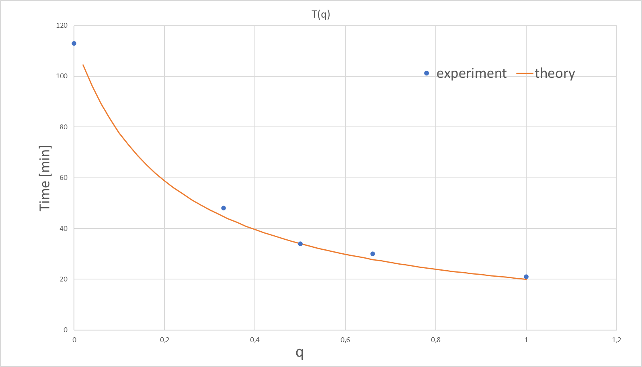

This assuming is correct to predict the drying time.

This last graph show the behaviour of humidity and temparutre during time of

°Poll e Analisi di mercato

To understand the needs of the population when it comes to drying clothes, a survey of a sample of 85 people was carried out. It was thus possible to know the demand for the sample and evaluate the supply of our project accordingly. It was thus possible to understand if our project was going in the right direction, and possibly add/remove particular features that our project planned to have in the initial idea.

The decisive results of our survey are given below.

It was found that 73.5% of the sample thought it was 'quite'/so important that clothes take little to dry. Yet only 37 % have a dryer. In fact, 76.5% say they prefer a faster but cheaper drying system while 89.4% prefer less speed and low consumption. This can justify the low preference of dryers at the home of families. In addition, the low noise of the device (61.2%) and the small footprint (89.4% say 'enough/so important).

Da completare

°Conclusion

°References

PHYSICAL DESCRIPTION

In a paper on drying phenomena we found that following graphs for the moisture content over time, at different speed, temperature and humidity of the air:

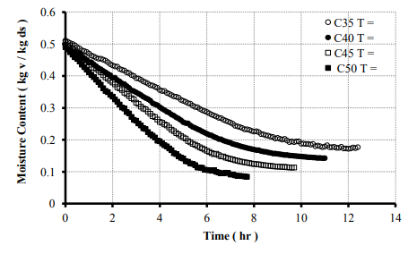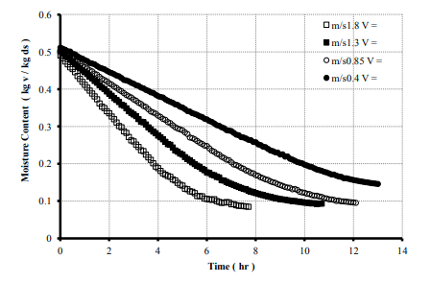

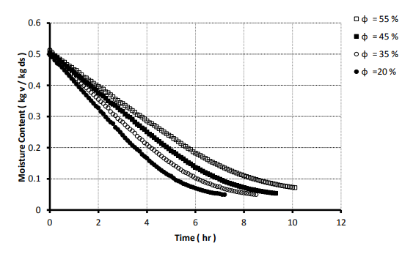

From those graphs we can conclude two important things:

* the dryng process is faster if the air around clothes have higher temperature is dryer and is faster.
* the moisture content can be approximated as a linear function of time:

Where is the mass transfer coefficient that is constant for fixed.

This relation (that will be verified in the experiment paragraph) tells us an important thing about our system: no efficient energy saving strategy can be made. Infact if we produce a system that when is on increase from to the time to dry the clothes will be .

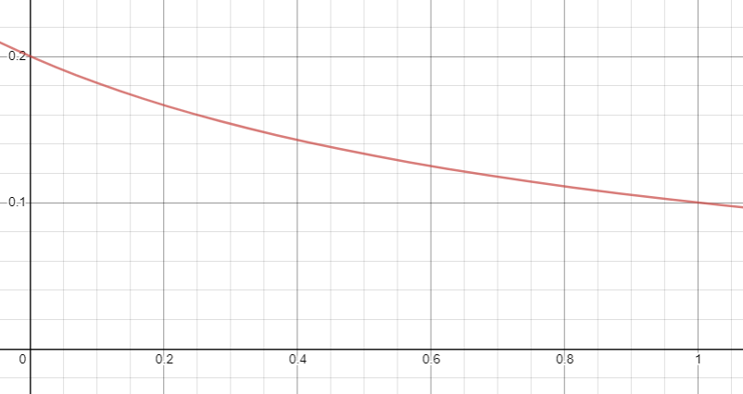If we want to save energy we must turn off the system once in a while, let’s say that we turn on the system for a time and off for a time . We can use different strategy for example: turn on for 1 min and off for 2 min and repeat until the clothes are dry. In the end the total mass expelled when the system is on is and when is off, such that and the total time to dry the clothes is . If we call that represent the chosen strategy (example if q=0,5 the system is on half of the time).  
Whit some algebra: which graph is reported below

T

q

As we can see a minimum doesn’t ’t exist meaning that all the energy given to the drying system is effectively use to dry the clothes.